Bloom’s Critical Thinking Cue Questions
Cue Questions Based on Blooms’ Taxonomy of Critical Thinking
Lower-Order Thinking Skills Higher-Order Thinking Skills
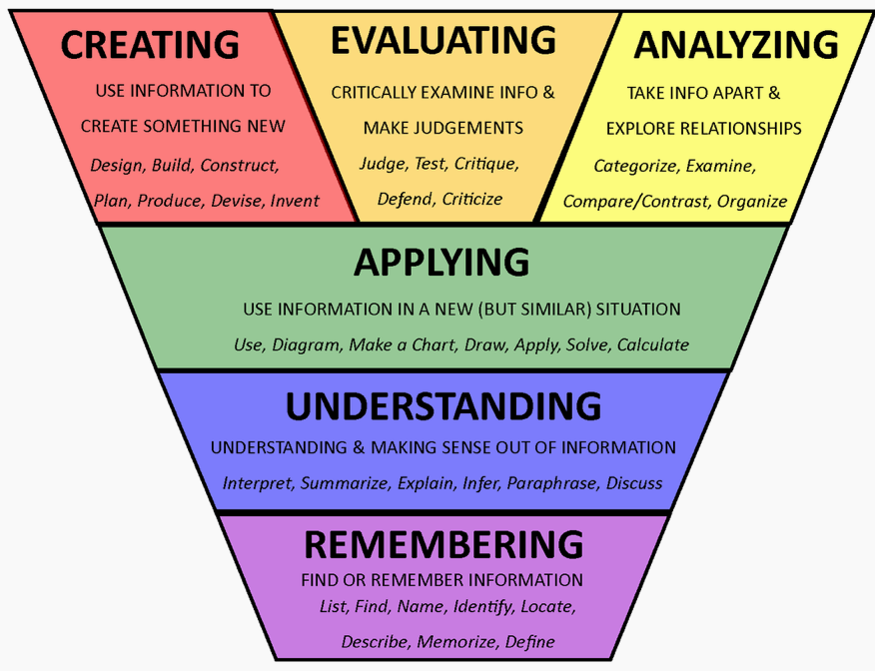

1. REMEMBERING  • What is ...? • How is ...? • Where is ...? • When did _______ happen? • How did ______ happen?  • How would you explain ...? • How would you describe ...? • What do you recall ...? • How would you show ...? • Who (what) were the main ...? • What are three ...? • What is the definition of...? | 4. ANALYZING  • What are the parts or features of ...?  • How is _______ related to ...?  • Why do you think ...? What is the theme ...?  • What motive is there ...?  • What conclusions can you draw ...?  • How would you classify ...?  • How can you identify the different parts ...?  • What evidence can you find ...?  • What is the relationship between ...?  • How can you make a distinction between ...?  • What is the function of ...? • What ideas justify ...?
2. UNDERSTANDING  • How would you classify the type of ...?  • How would you compare ...? contrast ...?  • How would you rephrase the meaning ...?  • What facts or ideas show ...?  • What is the main idea of ...?  • Which statements support ...?  • How can you explain what is meant ...?  • What can you say about ...?  • Which is the best answer ...?  • How would you summarize ...? | 5. EVALUATING  • Why do you agree with the actions? The outcomes?  • What is your opinion of ...?  • How would you prove ...? disprove ...?  • How can you assess the value or importance of ...?  • What would you recommend ...?  • How would you rate or evaluate the ...?  • What choice would you have made ...?  • How would you prioritize ...?  • What details would you use to support the view ...?  • Why was it better than ...?
3. APPLYING  • How would you use ...?  • What examples can you find to ...?  • How would you solve _______ using what you have learned ...?  • How would you organize _______ to show ...?  • How would you show your understanding of ...?  • What approach would you use to ...?  • How would you apply what you learned to develop ...?  • What other way would you plan to ...?  • What would result if ...?  • How can you make use of the facts to ...?  • What elements would you choose to change ...?  • What facts would you select to show ...?  • What questions would you ask in an interview with ...? | 6. CREATING  • What changes would you make to solve ...?  • How would you improve ...?  • What would happen if ...?  • How can you elaborate on the reason ...?  • What alternative can you propose ...?  • How can you invent ...?  • How would you adapt ________ to create a different ...?  • How could you change (modify) the plot (plan) ...?  • What could be done to minimize (maximize) ...?  • What way would you design ...?  • What could be combined to improve (change) ...?  • How would you test or formulate a theory for ...?  • What would you predict as the outcome of ...?  • How can a model be constructed that would change ...?  • What is an original way for the ...?

